PROJECT DOCUMENTATION / FINAL PROJECT REPORT

Final Project Report
Incident Life Cycle Automation - consolidated project report
DATE  07 October 2026 | STUDENT NAME  Gangadevi.R | PROJECT  Incident Life Cycle Automation

1. Introduction

1.1 Project Overview
Incident Life Cycle Automation is a workflow-oriented system designed to manage operational incidents as one continuous, traceable lifecycle. The project focuses on reducing manual coordination by automating intake, triage, assignment, SLA monitoring, escalation, resolution and closure.

1.2 Purpose
The purpose is to improve response visibility, ownership, consistency and auditability without introducing unnecessary scope beyond the incident lifecycle itself.

2. Ideation Phase

2.1 Problem Statement
Incident handling can be fragmented across manual steps, leading to delayed ownership, unclear status, missed SLA actions and incomplete history.

2.2 Empathy Map Summary
- Users need a simple reporting path and transparent status.
- Support teams need complete incident context and clear ownership.
- Managers need early SLA risk visibility and escalation control.
- Auditors need reliable lifecycle history.

2.3 Brainstorming
The selected initial scope prioritizes the highest-value, feasible ideas: structured intake, automated routing, SLA monitoring, escalation, lifecycle status, resolution and audit history.

3. Requirement Analysis

3.1 Customer Journey Map
The target journey is: notice issue -> report -> receive ownership -> track progress -> respond to escalation -> confirm resolution -> close and review.

3.2 Solution Requirements
Core requirements cover incident intake, identification, classification, assignment, SLA tracking, notifications, investigation, resolution, closure, history, dashboard/search, access control and auditability.

3.3 Data Flow Diagram
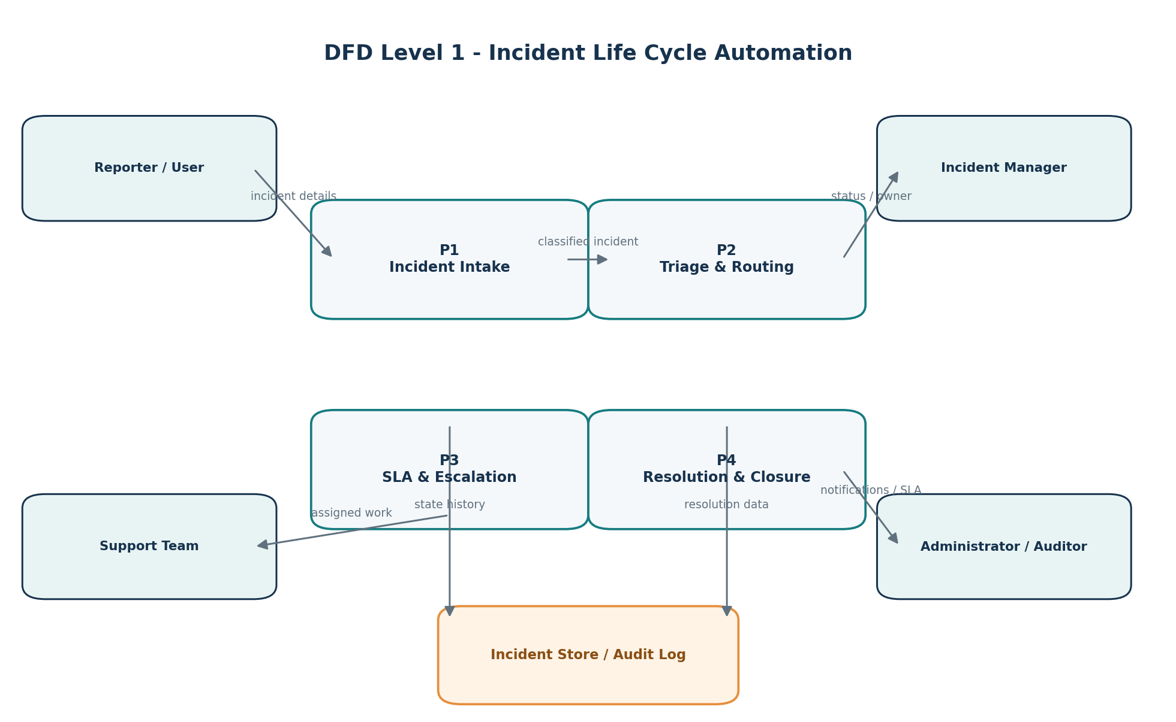

3.4 Technology Stack
Proposed stack: HTML/CSS/JavaScript for the interface, Python/Flask for application logic, SQLite/MySQL for persistence, a background scheduler/worker for SLA checks, and SMTP/email for notifications. This is a proposed project stack and should be aligned with the actual implementation before submission.

4. Project Design

4.1 Problem-Solution Fit
Each core automation directly addresses an observed lifecycle pain: structured intake reduces missing details, routing reduces ownership delay, SLA automation reduces late follow-up, and audit history reduces traceability gaps.

4.2 Proposed Solution
The solution automates incident intake, rule-based triage and assignment, SLA tracking, escalation, resolution, closure and lifecycle history. Each transition is time-stamped so ownership and status remain visible throughout the incident.

4.3 Solution Architecture
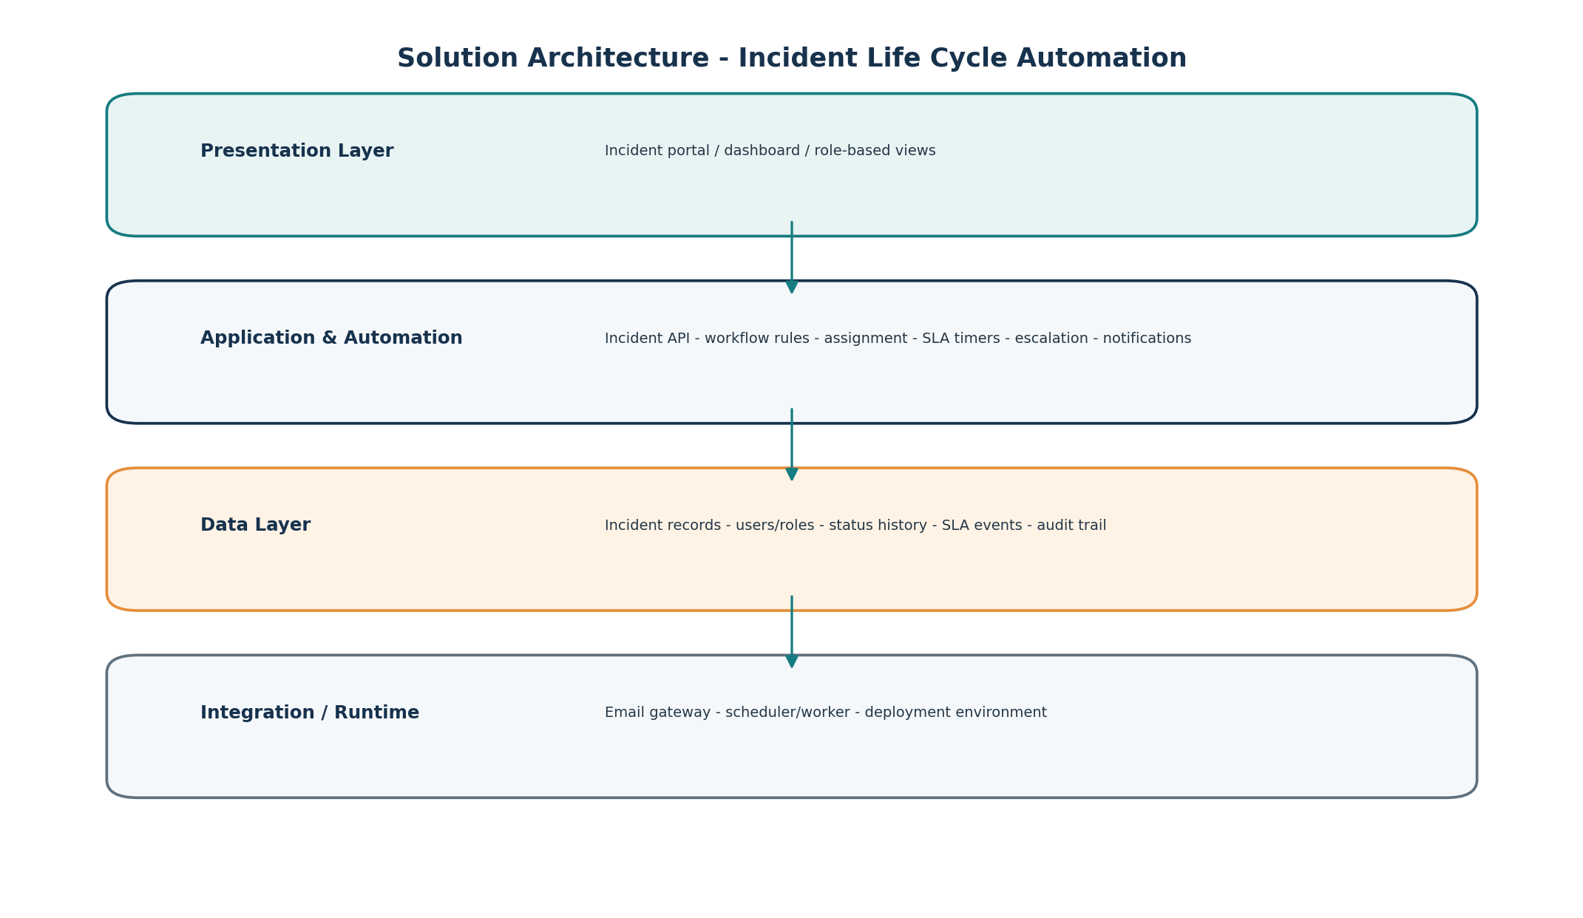

5. Project Planning & Scheduling

5.1 Project Plan
Sprint | Focus | Planned Points
Sprint 1 | Incident foundation - intake, triage, priority, assignment | 16
Sprint 2 | Active handling - status, investigation, resolution, SLA | 13
Sprint 3 | Operational visibility - dashboard, rules, audit, notifications | 13

6. Functional & Performance Testing

6.1 Functional Testing
Functional coverage includes positive and negative incident creation, assignment, status changes, SLA behavior, resolution, closure, search and role-based actions.

6.2 Performance Testing
Performance checks measure incident creation, detail retrieval, search/filtering, scheduled SLA processing and concurrent updates. Actual timings must be captured from the implemented system rather than assumed.

6.3 User Acceptance Testing
UAT validates that the complete user workflow matches expected operational behavior and records any defects or sign-off decisions.

7. Results
The final results section should contain screenshots from the implemented application, including: incident creation, incident detail/timeline, assignment, SLA state, dashboard/search and closure/audit history. Attach measured test outcomes from execution.
Implementation Screenshot 1
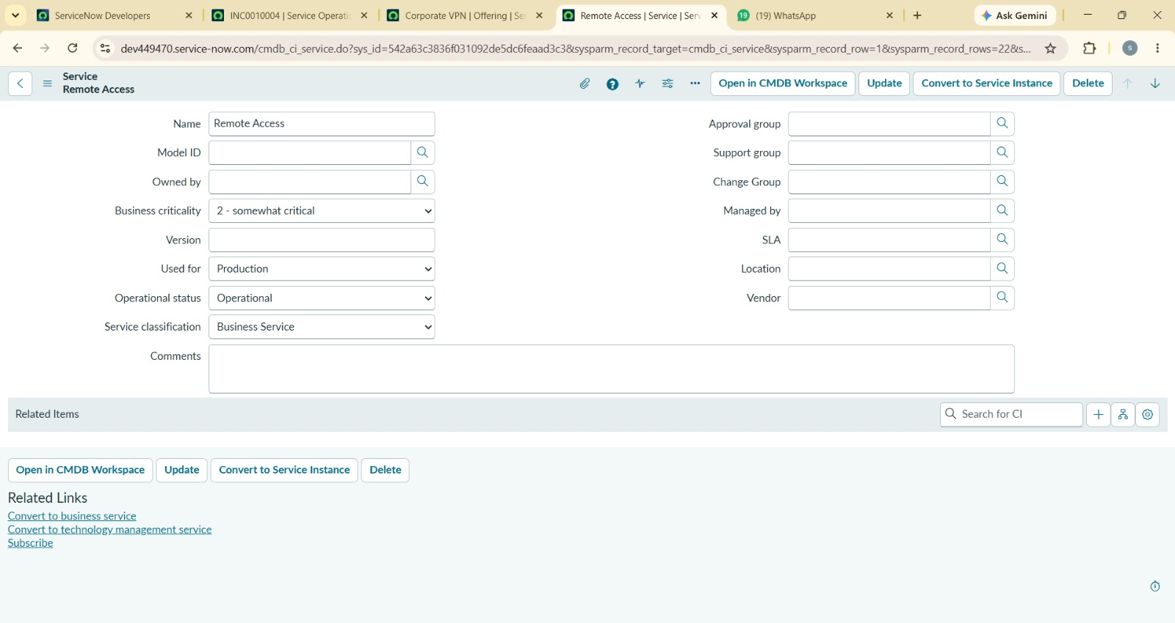
Implementation Screenshot 2
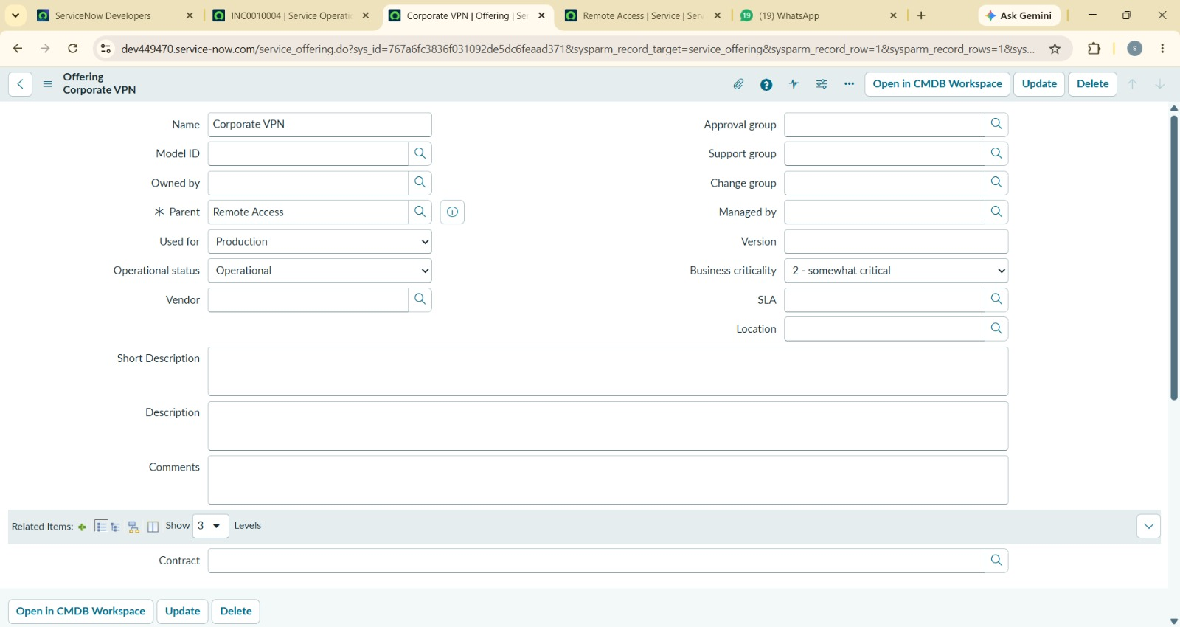
Implementation Screenshot 3
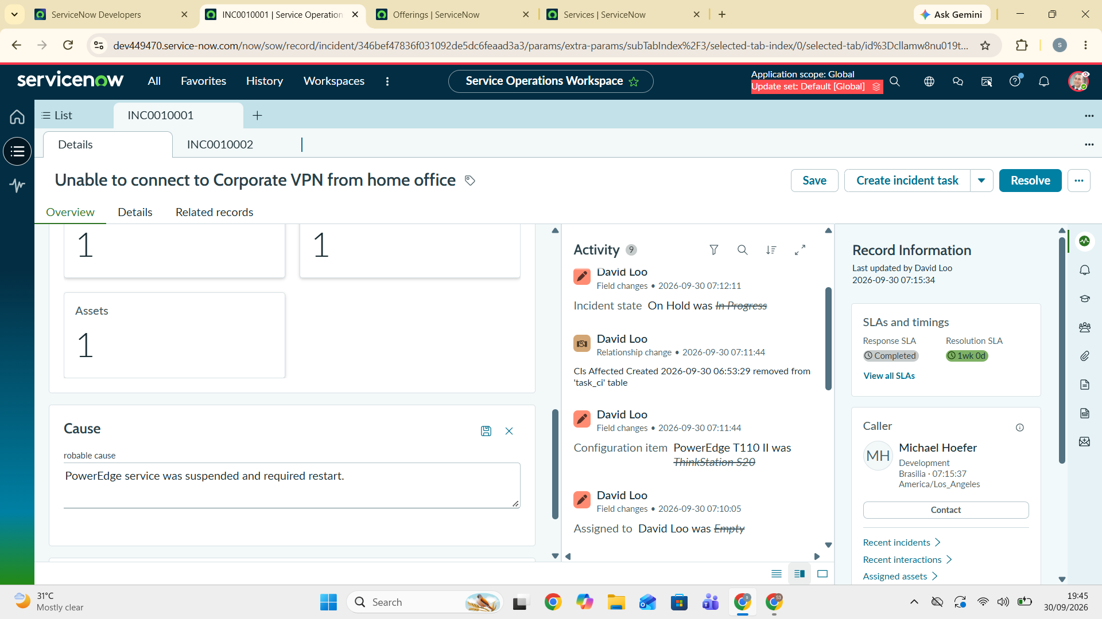
Implementation Screenshot 4
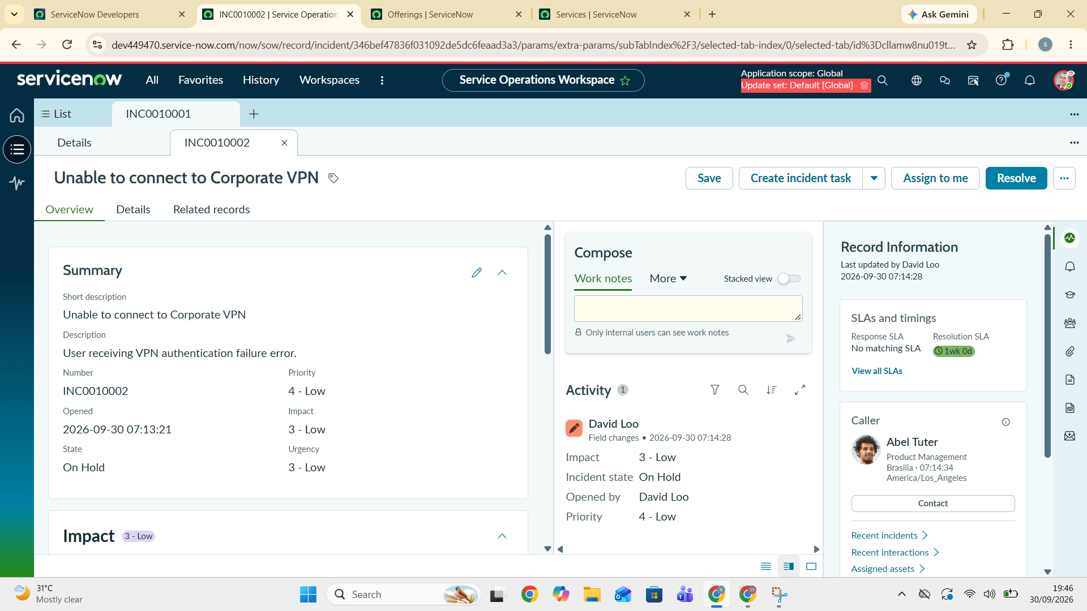
Implementation Screenshot 5
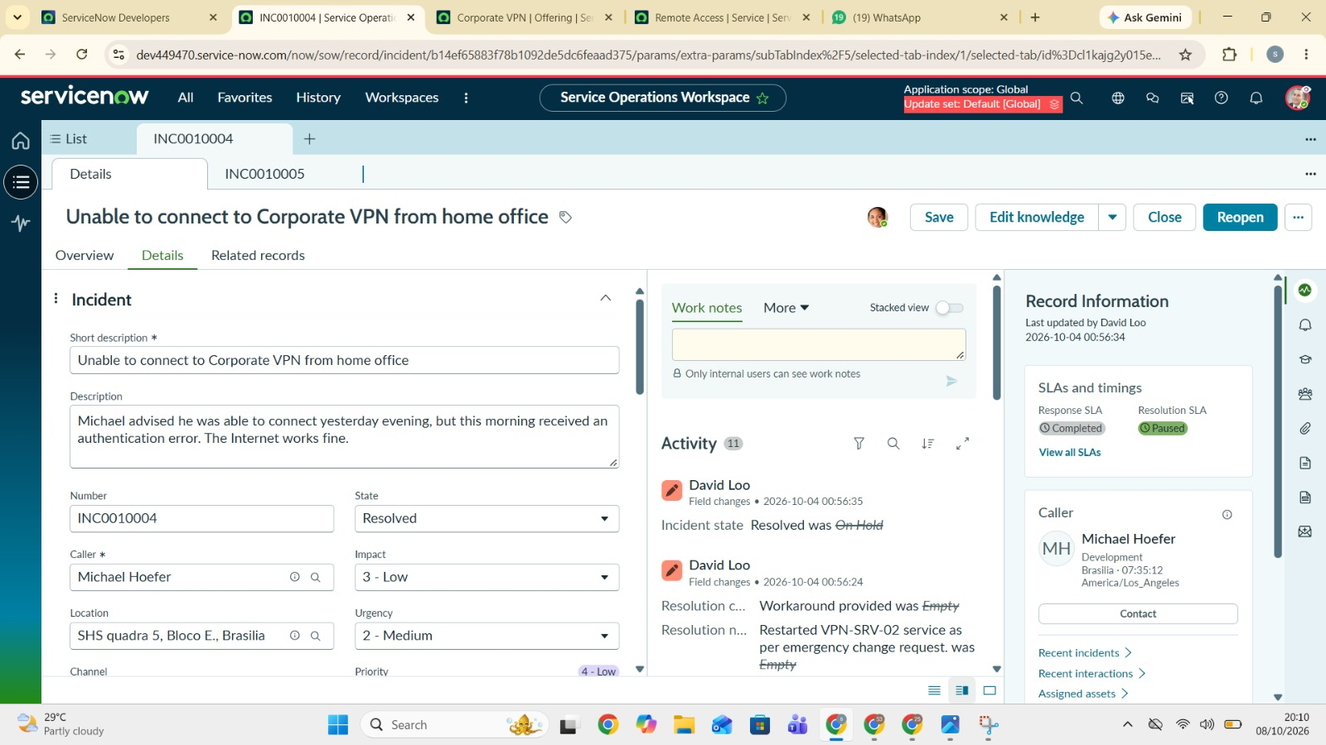

8. Advantages & Limitations
Advantages | Limitations
Clear ownership and lifecycle visibility | Initial scope is limited to core incident automation
Reduced repetitive manual follow-up | Advanced integrations are outside the initial build
SLA-driven escalation | Performance depends on deployment environment
Consistent status history and audit trail | Rules require correct configuration

9. Conclusion
Incident Life Cycle Automation converts a fragmented incident-handling process into a rule-driven workflow. The project is designed to improve operational visibility, reduce manual coordination and preserve a reliable history from incident creation through closure.

10. Future Scope
- Service-specific SLA policies and more granular workflow rules
- External ticketing / email / messaging integrations
- Analytics for incident trends and recurring failure patterns

11. Appendix
- Source code: attach project repository or source archive.
- Project screenshots: attach implementation screenshots.
- Test evidence: attach executed UAT and performance results.
- Demo link: add only if an actual deployment exists.

